Run the house model online with Kaggle using the link below:

<https://www.kaggle.com/trungnguyen0987/house-model-no-input-data>

1st register and sign in with Kaggle then select Copy and edit.

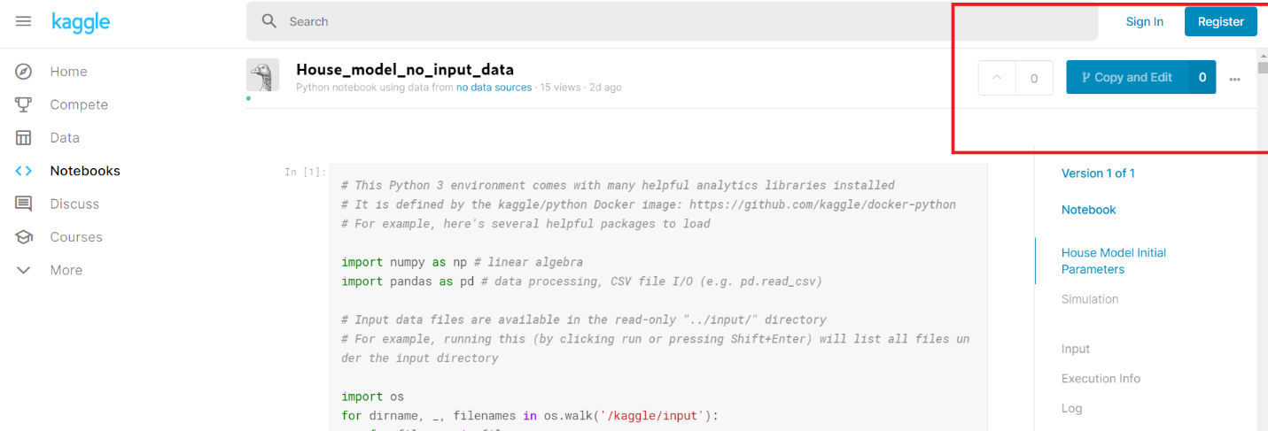

The house model uses NEN5060_2018 data as the input data file, the code for calculating irradiation on an outer surface has also been included. You can run the model by uploading the data and turn the internet button on (look at the pictures below on the right corner). NEN5060_2018 can be download from the NEN websites. Contact Paul or Trung for the file if you still cannot download it.

